APPLICATION FOR APPLYING CORRECTORS WITH COUPLED ERROR TO TOLERANCE ANALYSIS AND ERROR BUDGETS

Tyler Seawright
M.S. Mechanical Engineering

ERROR BUDGETS AND WHY THEY ARE FEARED
Error budgets are one of the last requests the typical engineer wants to hear and for good reason. We associate “budget” with the stress of deciding what to do with a scarce resource. However, without an error budget, intended performance of a system is impossible to guarantee. The backbone of every precision system is the error budget.

Engineers design incredibly complex systems and with each new system, a new error budget must be created. There is an ocean of details required to model basic cases and the old method of using Excel spreadsheets is tedious to set up, unstable, and completely unflexible. There is no clear method to capture coupled error motion from applying an error correction making 3D tolerance stacks unmanageable.

ERROR BUDGET DEFINITION
Error budgets apportion a total error to identified sources to drive design decisions. A good error budget identifies the sources the system is most sensitive to. The error model is more generalized and realistic when coupled motion error is considered in 3D space versus linear tolerance stacks. The concept of an error budget stems from GUM [1], serving as a guide for expressing measurement uncertainties “from the shop floor to research instruments.”

ABSTRACT PURPOSE
This abstract is intended to serve as a description of an open-source 3D mechanical tolerance stack application that includes a workflow to model complex systems with minimal setup time. A set of MATLAB functions are provided to allow for custom analysis; however, the focus of this abstract will be a single button embedded into Excel as a macro to solve 3D tolerance stacks with error correctors running a pre-compiled MATLAB script. A sample application will be presented in this abstract, highlighting the capabilities of the application and describe the workflow. The coordinate transform methods are modeled through homogeneous transform matrices (HTM) described by [2]. A new method for capturing coupled errors propagated from utilizing correctors is presented to generalize tolerance stacks including error correctors without small angle approximations. A built-in Montecarlo determines the $μ+Nσ$ error. This application does not focus on distinguishing types of error sources other than mechanical, but they are easily included if a sensitivity is provided. The equations to convert HTM to positions and angles are from [3].

ERROR MODEL
ERROR TRANFORM PATH USING HTM
The relative error between two points in six degrees of freedom is calculated by performing an inverse matrix multiplication of the nominal and errored absolute HTMs representing 4x4 matrix transform paths between two coordinate systems. The transform is generated by multiplying four base transforms, first with 321 rotations then with a single transform representing position. Then the coordinate system transforms are assembled and combined. First, the nominal transform path is solved for n coordinate systems in the base coordinate system, using right to left multiplication using eq 1. Second, the absolute transform path containing propagated errors is solved with an additional error term pre-multiplied with each respective coordinate system described by eq. 2. Last, the relative error transform between nominal and absolute transform paths is solved by eq. 3.

$T_{0}^{n}=T_{0}^{1}*T_{1}^{2}*…*T_{n-1}^{n}$ (eq. 1)
${Te}_{0}^{n}=E_{0}^{1}T_{0}^{1}*E_{1}^{2}T_{1}^{2}*…*{E_{n-1}^{n}T}_{n-1}^{n}$ (eq. 2)
${Re}_{0}^{n}=T_{0}^{n}\backslash {Te}_{0}^{n}$ (eq. 3)

CORRECTOR ERROR PROPAGATION
Correctors pose a challenge in precision engineering because when they are used, there may be coupled motion, which is not trivial to quantify for random system error. The coupled motion to move the system from an arbitrary position transformed to the corrected position is applied. An example of this phenomenon is using a tip/tilt correction, if the rotation axis is not through the system point of interest, a parasitic error motion is added to the system when the correction is performed on one axis. This is most useful when determining the range of adjustment required and if more adjustments are needed. Additionally, this information will indicate if using the corrector pushes a different axis out of the required range when used.

The corrector is applied by solving the corrector difference matrix which is the HTM representing how far the point of interest is from the corrector on the axes of compensation. The inverse corrector difference transform is then applied the corrector vector to point of interest and then to the absolute position HTM to rotate to the corrector position and propagate the parasitic rotation to the coupled axes.

- Solve relative HTM error vector $E_{re}$ from the transform using method described by [2].
- Generate corrector difference vector for all corrector values defined. Ignoring non-corrector defined values done in program.
$C_{D}=C-E_{re}$ (eq. 4)
- Generate transform from point of interest to corrector $T_{VC}$.
- Generate corrector difference transform $T_{CD}$.
- Solve absolute error applying corrector at distance from point of interest.
$T_{cae}=T_{ae}(T_{VC}\backslash (T_{CD}*T_{VC}))$ (eq. 5)
- Solve relative error post-applying corrector using method from [2].

MODEL VALIDATION
The model was validated by testing a few cases in which an error was applied to a vector and then corrected using Demo_Error_Budget_1.m.

In the second example, a 1mm in the x direction is used as the transform path. A 0.017 rad [1°] error is applied about the z axis. The corrector corrects at a resolution of 2.5mrad about the z axis and is located at origin in the x direction. Ra represents absolute position, Re represents relative position, and Rec represents corrected relative position.

The results are as expected. The corrected error leaves the corrector resolution on the axis of adjustment and the coupled error in x and y was reduced by the delta to move the system to the corrected location.

Table 1. [CHECK FORMATTING]
Vector Name | X | Y | Z | $$θ_{x}$$ | $$θ_{y}$$ | $$θ_{z}$$
Ra | 0.9999 | 0.0170 | 0 | 0 | 0 | 0.0170
Re | -0.0001 | 0.0170 | 0 | 0 | 0 | 0.0170
Rec | 0 | 0.0025 | 0 | 0 | 0 | 0.0025

The second error example uses Demo_Error_Budget_2 which is slightly more complicated by moving the corrector position to 2 on the x axis. Since the corrector is not rotating about the axis through the point of interest, coupled error motion is added when using the corrector. At position x = 1 from the point of interest, the corrector rotates the point of interest in the negative direction about z, thus increasing the y position and decreasing the x position with respect to the origin by approximately the same amount. The expected position change between Re and Rec is the difference of angle error and corrector resolution applied as a rotation to the nominal position vector.

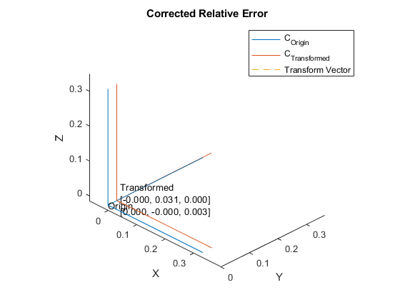
FIGURE X.

Table 2 [CHECK FORMATTING]
Vector Name | X | Y | Z | $$θ_{x}$$ | $$θ_{y}$$ | $$θ_{z}$$
Ra | 0.9999 | 0.0170 | 0 | 0 | 0 | 0.0170
Re | -0.0001 | 0.0170 | 0 | 0 | 0 | 0.0170
Rec | -0.0004 | 0.0031 | 0 | 0 | 0 | 0.0025

This is expandable to 6DOF and stacks of any length. With a well-defined math model, an entire mechanical tolerance stack with correctors in different places can be modeled.

ERROR BUDGET WORKFLOW
DEVELOP MATH MODEL
The math model represents the connection between parts of the error budget. This may include multiple coordinate transforms that are stacked, definition of correctors, and sensitivities within the system. In Excel, the math model is the user’s model connecting the stacks performed by the program. For a single stack, no math model is required.

INPUT VECTOR LOOPS, ERROR TERMS, AND CORRECTORS
In a screenshot, a sketch of the vector path to each part interface is helpful to organize the model. FIGURE 1 depicts a sample vector path and the Excel spreadsheet representing the inputs.

[Will be added in long abstract]
FIGURE 1. Math model for tolerance analysis used in sample application.

The model is input into a spreadsheet as a list of 6 DOF vectors and relative errors. Since errors are relative, they may be input as the part tolerances in the part’s local coordinate system. Each type of input is tagged to make the spreadsheet dynamic for MATLAB to parse as it becomes complex. When the system is solved, the cells containing the inputs must be highlighted.

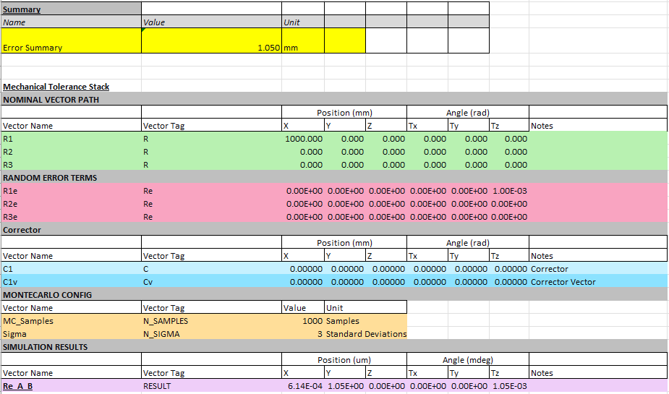
FIGURE 2. The spreadsheet includes all the inputs read by the program. The Error Summary is an example of using a custom math model calculated from the RESULT where the script outputs the solution.

A corrector must be defined with a vector from the corrector to a point of interest and must contain a vector describing the resolution of the corrector per axis of correction. Cells with zeros will be ignored.

MONTECARLO CONFIGURATION
The analysis runs a Montecarlo requiring input for number of samples and input standard deviation range. By default, the inputs are varied by normal distribution centered at zero.

RUNNING THE MODEL
To perform the analysis, highlight the group of cells containing the tagged inputs and run the macro. The macro will only read and write within the range of highlighted cells such that complex systems with loose formatting can be applied within Excel and only the specified calculations are performed.

REVIEW RESULTS
Results are output to the spreadsheet where specified by tag in the highlighted range. The result is the 6DOF $μ+Nσ$ transform vector considering the entire tolerance path where $μ$ is the mean, $N$ is the specified number of standard deviations, and $σ$ is standard deviation. The script saves results, plots histograms and coordinate transforms depicted in FIGURE 3, and places figures in the spreadsheet below RESULTS.

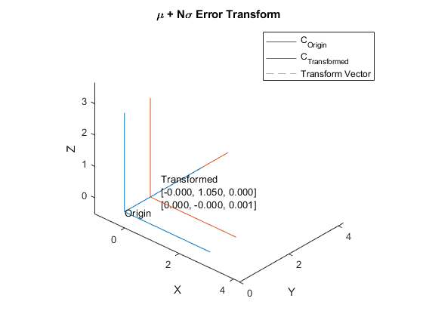
FIGURE 3. A 1m x-axis lever arm wiggled by ±1° in theta z for 1000 normally distributed samples results in ±1mm 3$σ$ error in y, ±1° 3$σ$ error in theta z, and all x error is negative.

For building larger systems, an additional macro and MATLAB function is provided to plot sets of transforms to visualize complex behavior shown in FIGURE 4. Multiple sets of inputs may be combined in one spreadsheet and linked to a master sheet with system level errors making this program scalable.

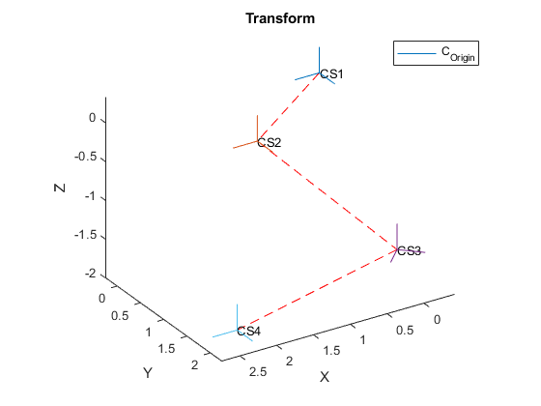
FIGURE 4. A chain of coordinate systems is plotted to represent a system.

SAMPLE APPLICATION: OPTICAL ALIGNMENT
SYSTEM OVERVIEW AND REQUIREMENTS
The sample system is an axial-symmetric mirror that reflects a collimated beam to hit a target a specific angle and position. The engineer does not know if the mirror can be fixed or requires error correction. The beam is aligned first to a tooling target within 0.05mm before the mirror is inserted into the assembly to direct the beam to a new target. The angle of the beam must fall within 100mdeg at the target with respect to the tooling target. Given the beam is 4mm diameter and clear aperture (CA) of the mirror is 5mm. Because of a nearby beam, a shift in Z by 1mm causes clipping. If an error corrector is to be used, it must satisfy the requirements. TABLE 1. outlines the sample application requirements derived from the sample optical requirements.

Requirement | Value | Unit
Mirror Centration (x,y,z) | 0.45  0.45  1.0 | mm  mm  mm
Mirror Orientation (Tx, Ty, Tz) | 1.74  1.74  20 | mrad  mrad  mrad
TABLE 1. Sample requirement table. All requirements are in the target coordinate system relative to tooling target.

ERROR MODEL
To be added in Long-Abstract

MODEL OUTPUTS
To be added in Long-Abstract

CONCLUSION
To be added in Long-Abstract

REFERENCES
- Joint Committee for Guides in Metrology. Evaluation of measurement data – Guide to the expression of uncertainty in measurement. 2008.
- A. H. Slocum, Precision Machine Design. Prentice-Hall, Inc., 1992.
- Duenner, Andrew C. An Error Budgeting Framework for Engineering Design. Massachusetts Institute of Technology. 2019.

